**Inter VLAN Routing Configuration**

**Designed Topology:**

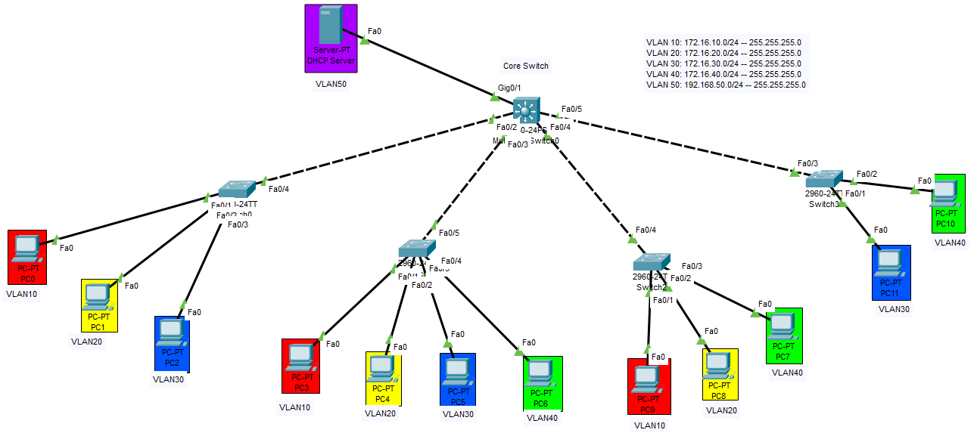

**Configuration of Multilayer Switch0:**

Switch>enable

Switch#config terminal

Switch(config)#int fa0/2

Switch(config-if)#switchport trunk encapsulation dot1q

Switch(config-if)#switchport mode trunk

Switch(config-if)#exit

Switch(config)#int fa0/3

Switch(config-if)#switchport trunk encapsulation dot1q

Switch(config-if)#switchport mode trunk

Switch(config-if)#exit

Switch(config)#int fa0/4

Switch(config-if)#switchport trunk encapsulation dot1q

Switch(config-if)#switchport mode trunk

Switch(config-if)#exit

Switch(config)#int fa0/5

Switch(config-if)#switchport trunk encapsulation dot1q

Switch(config-if)#switchport mode trunk

Switch(config-if)#exit

Switch(config)#exit

Switch#write

Switch#config terminal

Switch(config)#vtp mode server

Switch(config)#vtp domain NET

Switch(config)#exit

Switch#write

Switch#config terminal

Switch(config)#vlan 10

Switch(config-vlan)#name MUET

Switch(config-vlan)#exit

Switch(config)#vlan 20

Switch(config-vlan)#name UOS

Switch(config-vlan)#exit

Switch(config)#vlan 30

Switch(config-vlan)#name LUMHS

Switch(config-vlan)#exit

Switch(config)#vlan 40

Switch(config-vlan)#name NED

Switch(config-vlan)#exit

Switch(config)#vlan 50

Switch(config-vlan)#name MANAGEMENT

Switch(config-vlan)#exit

Switch(config)#exit

Switch#write

Switch#sh vlan

Switch#config terminal

Switch(config)#int Gig0/1

Switch(config-if)#switchport mode access

Switch(config-if)#switchport access vlan 50

Switch(config-if)#exit

Switch(config)#exit

Switch#write

Switch#config terminal

Switch(conf)#int vlan 10

Switch(conf-if)#ip address 172.16.10.254 255.255.255.0

Switch(conf-if)#ip helper-address 192.168.50.1

Switch(conf-if)#exit

Switch(conf)#int vlan 20

Switch(conf-if)#ip address 172.16.20.254 255.255.255.0

Switch(conf-if)#ip helper-address 192.168.50.1

Switch(conf-if)#exit

Switch(conf)#int vlan 30

Switch(conf-if)#ip address 172.16.30.254 255.255.255.0

Switch(conf-if)#ip helper-address 192.168.50.1

Switch(conf-if)#exit

Switch(conf)#int vlan 40

Switch(conf-if)#ip address 172.16.40.254 255.255.255.0

Switch(conf-if)#ip helper-address 192.168.50.1

Switch(conf-if)#exit

Switch(conf)#int vlan 50

Switch(conf-if)#ip address 192.168.50.254 255.255.255.0

Switch(conf-if)#ip helper-address 192.168.50.1

Switch(conf-if)#exit

Switch(conf)#spanning-tree mode pvst

Switch(conf)#ip routing

Switch(conf)#exit

Switch#write

**Configuration of Switch0:**

Switch>enable

Switch#config terminal

Switch(config)#hostname SW0

SW0(config)#vtp mode client

SW0(config)#vtp domain NET

SW0(config)#exit

SW0#write

SW0#sh vlan

SW0#config terminal

SW0(config)#int fa0/4

SW0(config-if)#switchport mode trunk

SW0(config-if)#exit

SW0(config)#int fa0/1

SW0(config-if)#switchport mode access

SW0(config-if)#switchport access vlan 10

SW0(config-if)#exit

SW0(config)#int fa0/2

SW0(config-if)#switchport mode access

SW0(config-if)#switchport access vlan 20

SW0(config-if)#exit

SW0(config)#int fa0/3

SW0(config-if)#switchport mode access

SW0(config-if)#switchport access vlan 30

SW0(config-if)#exit

SW0(config)#exit

SW0#write

**Configuration of Switch1:**

Switch>enable

Switch#config terminal

Switch(config)#hostname SW1

SW1(config)#vtp mode client

SW1(config)#vtp domain NET

SW1(config)#exit

SW1#write

SW1#sh vlan

SW1#config terminal

SW1(config)#int fa0/5

SW1(config-if)#switchport mode trunk

SW1(config-if)#exit

SW1(config)#int fa0/1

SW1(config-if)#switchport mode access

SW1(config-if)#switchport access vlan 10

SW1(config-if)#exit

SW1(config)#int fa0/2

SW1(config-if)#switchport mode access

SW1(config-if)#switchport access vlan 20

SW1(config-if)#exit

SW1(config)#int fa0/3

SW1(config-if)#switchport mode access

SW1(config-if)#switchport access vlan 30

SW1(config-if)#exit

SW1(config)#int fa0/4

SW1(config-if)#switchport mode access

SW1(config-if)#switchport access vlan 40

SW1(config-if)#exit

SW1(config)#exit

SW1#write

**Configuration of Switch2:**

Switch>enable

Switch#config terminal

Switch(config)#hostname SW2

SW2(config)#vtp mode client

SW2(config)#vtp domain NET

SW2(config)#exit

SW2#write

SW2#sh vlan

SW2#config terminal

SW2(config)#int fa0/4

SW2(config-if)#switchport mode trunk

SW2(config-if)#exit

SW2(config)#int fa0/1

SW2 (config-if)#switchport mode access

SW2(config-if)#switchport access vlan 10

SW2(config-if)#exit

SW2(config)#int fa0/2

SW2(config-if)#switchport mode access

SW2(config-if)#switchport access vlan 20

SW2(config-if)#exit

SW2(config)#int fa0/3

SW2(config-if)#switchport mode access

SW2(config-if)#switchport access vlan 40

SW2(config-if)#exit

SW2(config)#exit

SW2#write

**Configuration of Switch3:**

Switch>enable

Switch#config terminal

Switch(config)#hostname SW3

SW3(config)#vtp mode client

SW3(config)#vtp domain NET

SW3(config)#exit

SW3#write

SW3#sh vlan

SW3#config terminal

SW3(config)#int fa0/3

SW3(config-if)#switchport mode trunk

SW3(config-if)#exit

SW3(config)#int fa0/1

SW3(config-if)#switchport mode access

SW3(config-if)#switchport access vlan 30

SW3(config-if)#exit

SW3(config)#int fa0/2

SW3(config-if)#switchport mode access

SW3(config-if)#switchport access vlan 40

SW3(config)#exit

SW3#write

**IP Configuration of DHCP Server:**

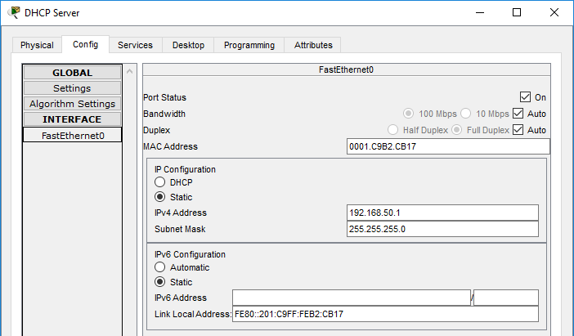

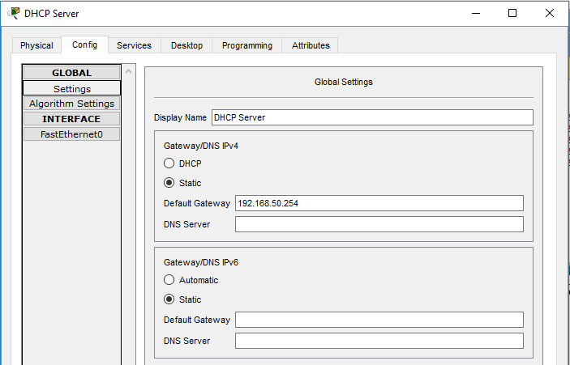

**Creating DHCP Pools:**

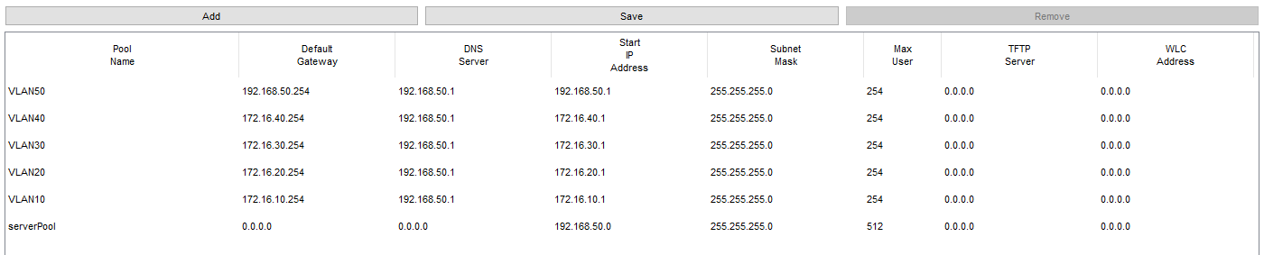

After Adding Pools in DHCP service , you can assign IP addresses to different PCs of different VLANs by using DHCP (Dynamic Host Configuration Protocol) Method. Let’s assign the IP addresses to all PCs connected with Switch1 and check whether DHCP protocol works or not.

**IP Configuration of PCs connected with Switch1:**

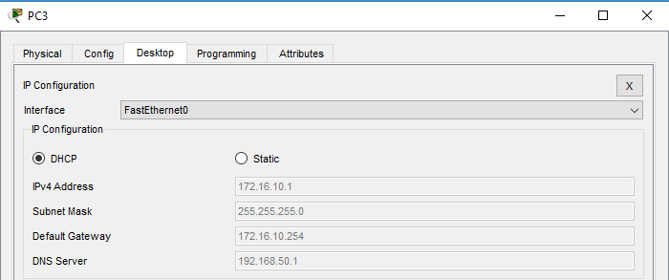

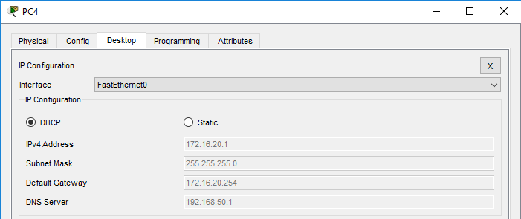

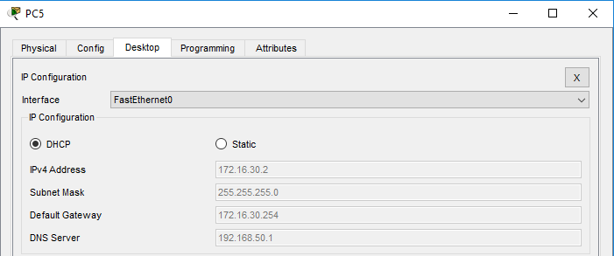

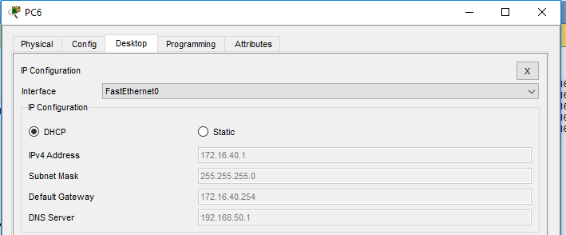

**Checking connectivity by pinging from VLAN10 PC to VLAN40 PC:**

